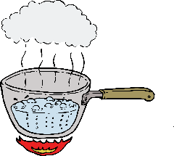
PWSD #2 of Lincoln County
40 Sydnorville Road
Troy, MO 63379
636-462-5911
(Office Hours: 8:30-4:00)

BOIL WATER ADVISORY-INSTRUCTIONS

THE FOLLOWING PRECAUTIONS SHOULD BE OBESERVED.
- Boil water vigorously for three minutes prior to use. Use only boiled water for drinking, brushing teeth, diluting fruit juice, and all other food preparations or consumption. WATER USED FOR DRINKING OR COOKING SHOULD BE BOILED AT A ROLLING BOIL FOR THREE (3) MINUTES PRIOR TO CONSUMPTION.
- Dispose of ice cubes and do not use ice from a household automatic ice maker. Remake ice cubes with water that has been boiled.
- Disinfect dishes and other food contact surface by immersion for at least one minute in clean tap water that contains teaspoon of unscented household bleach per gallon of water.
- Water used for bathing does not generally need to be boiled. Supervision of children is necessary while bathing or using backyard pools so water is not ingested. Persons with cuts or severe rashes may wish to consult their physicians.

NOTE: Let water cool sufficiently before drinking.

